News Story Picture

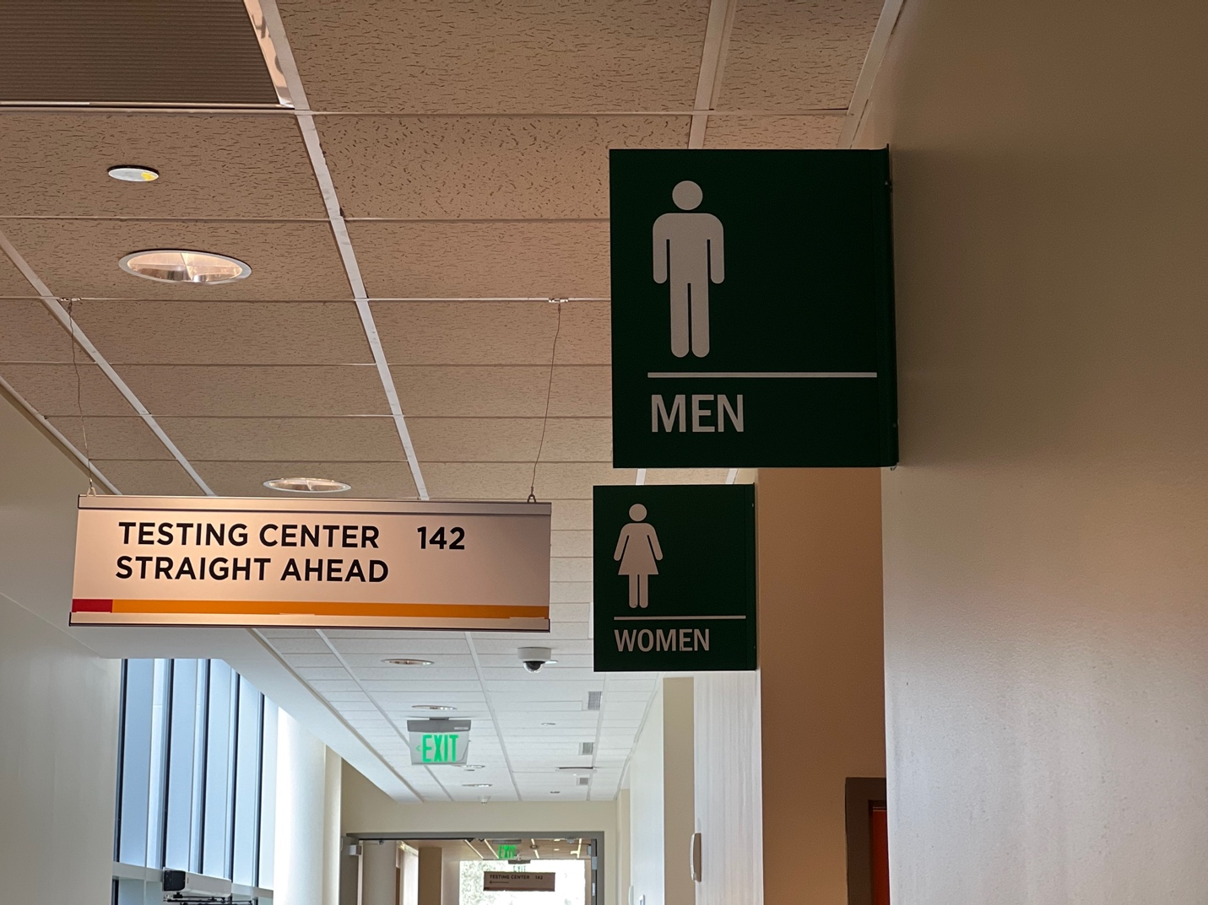

Female and Male Restrooms at Building 11, Valencia College's West Campus – Emily Reliquias

